

**Department of Computer Science and Engineering**

**Course :Blockchain Technology**

**Topic :** Microgrid Energy Trading on Blockchain

Submitted By- Shravya Bhamidipati (2022UCP1891)  
 Aryan Pingoliya (2022UCP1499)

# 1. Introduction

The **Microgrid Energy Trading on Blockchain** project implements a decentralized, peer-to-peer (P2P) energy trading system for microgrids using Ethereum-based smart contracts. The goal is to enable energy exchanges between registered microgrids while ensuring transparency, security, and efficiency in energy trading.

Microgrids are small, localized energy systems that can operate independently or in conjunction with a larger grid. By implementing a blockchain-based trading system, the project aims to empower microgrids to sell surplus energy directly to other microgrids or consumers. The system utilizes smart contracts to automate and record energy transactions, ensuring secure and efficient operations without the need for intermediaries.

# 2. Project Objectives

### 2.1. Decentralized Energy Trading :

Facilitate the direct exchange of energy between microgrids without the need for centralized intermediaries.

### 2.2. Transparency and Security :

Ensure that all energy trades are securely recorded on the blockchain and that all participants have access to transparent information.

### 2.3. Automated Transactions:

Use smart contracts to automate energy listings, buying, and price adjustments.

### 2.4. Microgrid Empowerment:

Enable microgrids to sell energy surplus directly to other microgrids or consumers, improving energy efficiency and profitability

# 

# 

# 3. System Architecture

The system architecture consists of the following key components:

### 3.1 Microgrids:

Represent energy producers or consumers who participate in the energy market. Microgrids can sell surplus energy to other microgrids or buyers.

### 3.2 Smart Contract:

The core component deployed on the Ethereum blockchain that handles the registration of microgrids, energy listings, bidding, transactions, and balance updates.

### 3.3 Blockchain:

The decentralized network that stores all transactions, ensuring that they are immutable and transparent. Ethereum is the chosen platform for implementing the smart contract.

### 3.4 Users (Buyers and Sellers):

Buyers place bids for energy, and sellers offer energy for sale. These participants can interact with the smart contract to buy and sell energy.

### 3.5 Blockchain Network (Ethereum):

The Ethereum blockchain serves as the platform for executing smart contracts and recording transactions.

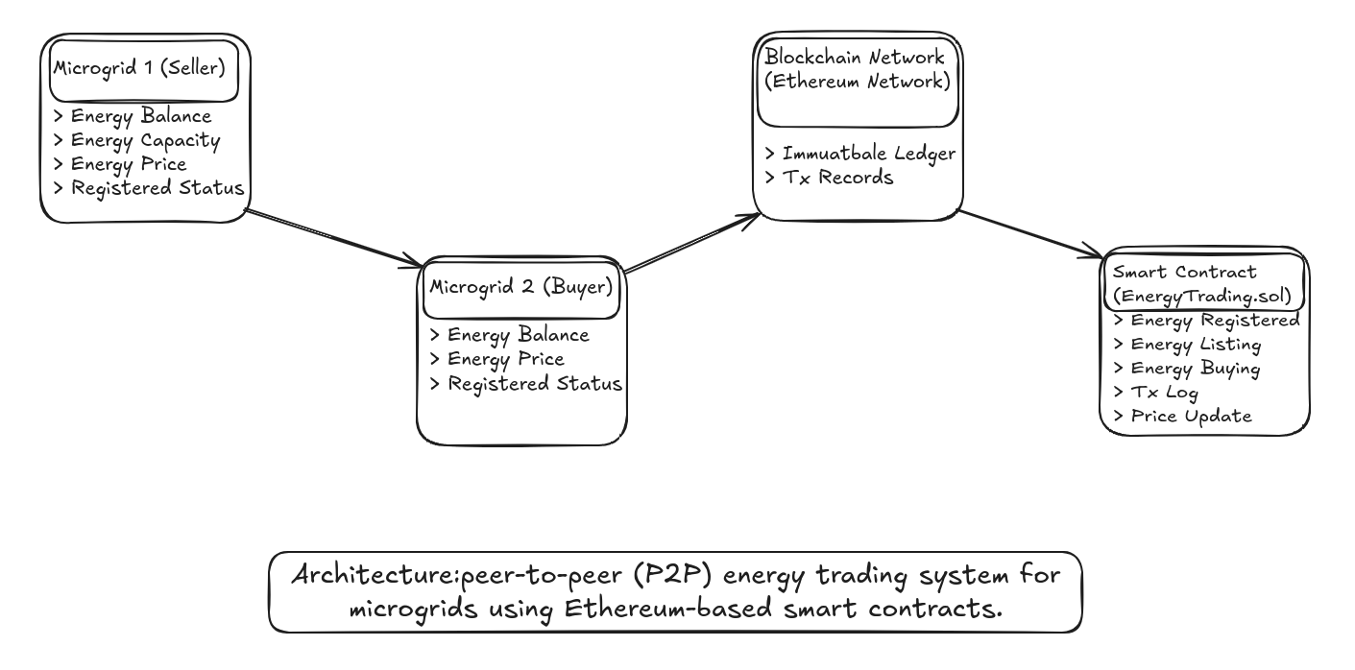

# 4. Functional Design

### 4.1. Microgrid Registration

- Purpose: Microgrids must register with the system to begin trading energy.

- Details: Upon registration, a microgrid provides its maximum energy capacity and energy price. The contract records this information and sets the microgrid’s available energy balance to match the capacity.

### 4.2. Energy Listing

- Purpose: A registered microgrid can list energy for sale.

- Details: The microgrid specifies the amount of energy it wishes to sell. The smart contract ensures the microgrid has sufficient energy in its balance before listing the energy for sale.

### 4.3. Energy Buying

- Purpose: A buyer (another microgrid or consumer) can purchase energy from a seller.

- Details: A buyer selects an amount of energy to purchase and sends the equivalent Ether. The smart contract ensures the transaction is valid by checking that the seller has enough energy and that the buyer provides the required payment. The energy balance is updated after the transaction.

### 4.4. Price Updates

- Purpose: A microgrid can adjust its energy price based on supply-demand factors.

- Details: Registered microgrids can update their energy price to reflect changing market conditions.

### 4.5. Withdrawals

- Purpose: The contract owner (administrator) can withdraw accumulated Ether from the contract.

- Details: The contract owner can withdraw the balance from the smart contract if necessary, for example, to pay for system maintenance.

# 

# 

# 

# 5. Contract Code Explanation

### 

### 5.1. Microgrid Structure

The Microgrid structure stores critical data for each microgrid:

- energyCapacity: The maximum amount of energy that can be supplied by the microgrid.

- energyBalance: The amount of energy currently available for sale.

- energyPrice: The price per kWh of energy.

- registered: A boolean value that ensures a microgrid is registered before performing transactions.

### 5.2. Events

- EnergyRegistered: Fired when a new microgrid registers with the system.

- EnergyListed: Fired when a microgrid lists energy for sale.

- EnergyBought: Fired when a buyer purchases energy.

### 5.3. Functions

- registerMicrogrid: Registers a new microgrid and sets its energy capacity and price.

- listEnergyForSale: Allows a registered microgrid to list energy for sale. The amount of energy listed is deducted from the microgrid's available balance.

- buyEnergy: Allows a buyer to purchase energy from a seller. It checks the seller's energy balance and ensures the buyer has provided sufficient payment.

- updateEnergyPrice: Enables a registered microgrid to update its energy price.

- withdraw: Allows the contract owner to withdraw accumulated Ether from the contract.

# 

# 

# 6. Security Considerations

- Access Control: The contract ensures that only registered microgrids can list or buy energy. This is enforced through the onlyRegistered modifier.

- Insufficient Funds Handling: Before any energy transaction, the contract checks if the buyer has sent sufficient Ether for the trade and whether the seller has enough energy to fulfill the transaction.

- Funds Transfer: The contract ensures that Ether is securely transferred to the seller once the transaction conditions are met.

# 7. Conclusion

The Microgrid Energy Trading smart contract offers a novel approach to decentralized energy trading. By leveraging blockchain technology, it ensures transparency, security, and efficiency in microgrid energy transactions. The implementation is flexible, allowing for future scalability, and it provides a foundation for the integration of more advanced energy management systems. The project could serve as an essential building block for creating decentralized, sustainable energy markets in the future.

# 7. References

1. <https://github.com/saurabh1002/energy-trading-blockchain?tab=readme-ov-file>
2. <https://remix.ethereum.org/#lang=en&optimize=false&runs=200&evmVersion=null&version=soljson-v0.8.25+commit.b61c2a91.js>
3. <https://ieeexplore.ieee.org/document/9845096>